03 July 2025 – Received blog project topic assignment and instruction video preview.

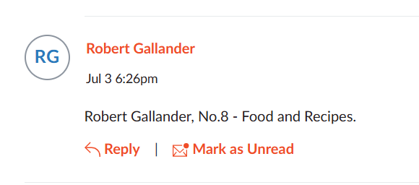

06-07 July 2025 – Watch first 2 hours of video, following along to create the folder and files. To easily change the file type ensure file name extensions are shown. Began coding the index.html and style.css files in Visual Studio Code after including Live Server, PHP Server, PHP Intelephense and Bracket Pair Color extensions.

Added the iconscout css link, but updates to the website force attribution without a subscription and had to copy the code from video. To personalize need to locate free repository of icons.

11-13 July 2025 – Finished the first 4hours of video to create a html webpage layout. Installed XAMPP php development environment. Started Apached and SQL modules. Error with the SQL conflicting with MySQL Workbench and had to stop the service.

18-19 July 2025 – Completed the video converting the html files to php, creating a database on phpMyAdmin, and finalizing a copy of the webpage.

21-23 July 2025 – Personalized the webpage to contain blog posts pertaining to my assigned Food/Recipe Topic.

24 July 2025 – Submitted project folder to GitHub: [rgall005/CSCI6073_project_gallander](https://github.com/rgall005/CSCI6073_project_gallander).